**September 29, 2021 NR21264wc**

***2 Men Arrested in Large Narcotics Investigation***

***Los Angeles:*** On September 28, 2021, Wilshire Narcotics Enforcement Detail (NED) served search warrants at four locations within the Greater Los Angeles Area. Wilshire NED conducted a long-term investigation regarding an illegal cannabis grow location within the mid-city area. Wilshire NED investigators identified owners and operators of the illegal grow operation.

During the months of July and August 2021, Wilshire NED was able to identify residences of owners involved. Wilshire NED was able to substantiate their investigation and obtained search warrants for four locations associated with the investigation.

On September 28, 2021, Wilshire NED, Gang Enforcement Detail along with DEA High Intensity Drug Trafficking Area (HIDTA) Group-51 served search warrants at the illegal cannabis grow locations and residences (Torrance and San Pedro) associated with the owners. Wilshire NED made two arrest during the service of the search warrants and recovered cannabis, two handguns and a substantial amount of U.S. Currency directly connected to illegal drug trade.

During the investigation Wilshire NED learned the illegal cannabis grow locations are supplying illegal dispensaries within the Mid-City and greater Los Angeles Area.

Wilshire NED arrested 35-year-old Alonso Armendariz for maintaining an illegal narcotics location and 54-year-old Lazaro Garcia for weapons violations and narcotics offenses. Detectives will submit the investigation to the Los Angeles County District Attorneys Office.

If anyone has information regarding this investigation, please contact Detective Marla Kiley, Wilshire Narcotics  Detectives, at (213) 473-0250 or e-mail 32556@lapd.online or Wilshire  Division Watch Commander at (213) 473-0459. During weekends and off-hours calls should be directed to the 24-hour toll free number at 1-877-LAPD-24-7 (1-877-527-3247).  For anonymous calls please call LA Regional Crime Stoppers at 1-800-222-TIPS (800-222-8477) or visit www.lacrimestoppers.org, or tipsters may also visit [www.lapdonline.org](http://www.lapdonline.org) and click on “Anonymous Web Tips” under the “Get Involved-Crime Stoppers” menu to submit an online tip. Lastly, tipsters may also download the “P3 Tips” mobile application and select the LA Regional Crime Stoppers as their local program.

**(page 1 of 2)**

 

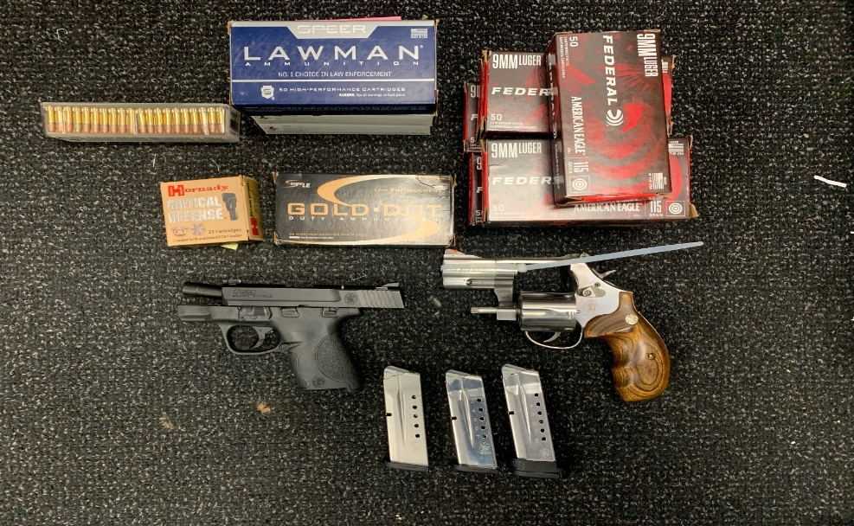

**(page 2 of 2)**

###