**September 15, 2021 NR21254ml**

***Wanted Felony Suspect***

***Los Angeles:***  Detectives from the Los Angeles Police Department’s Central Traffic Division are seeking information of the whereabouts of Tajon Wright Freeman a Wanted Felony Warrant Suspect.

On February 20, 2021, at 8:35 p.m., 30-year-old Tajon Wright Freeman, of Los Angeles, stole a 2001 Toyota Tundra in the area of 7th Street and Figueroa Street. As Freeman was fleeing the scene, he ran over a pedestrian who was crossing the street at the intersection of 7th Street and Figueroa Street. Freeman continued to flee in the truck without rendering aid or identifying himself; he abandoned the truck a short distance away on Bixel Street and Ingraham Street.

The Los Angeles Fire Department responded to the aid of a female pedestrian and transported her to a local hospital. She was admitted into the hospital with severe injuries. She has been discharged from the hospital and still recovering from her injuries.

Detectives were able to identify Freeman as the driver through DNA evidence left in the truck. Additionally, Freeman was also identified through DNA evidence in a Felony Vandalism case out of West Los Angeles Area. Both cases were presented to the Los Angeles District Attorney’s Office, and three felony counts were filed against Tajon Freeman, 594 P.C. Felony Vandalism, 487(d)(1) P.C. Grand Theft Auto, 20001(b)(1) V.C. Felony Hit and Run. On August 20, 2021 two felony warrants were issued for Freeman’s arrest.

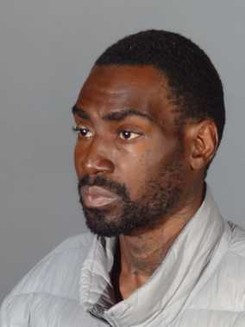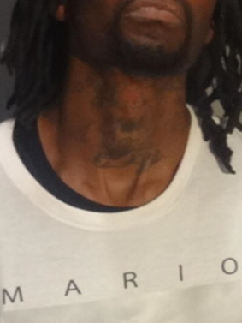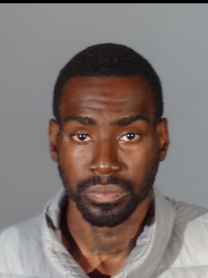

**Tajon Freeman**

Detectives have not been able to find Freeman who is currently experiencing homelessness. Detectives are seeking the public assistance with information on Freeman’s whereabouts. **Tajon Freeman is to be considered armed and dangerous. Do not approach him if seen.** If seen, immediately call 9-1-1. Anyone with information is asked to please contact Detective Campos, Central Traffic Detectives, at (213) 833-3713, or e-mail him at 31480@lapd.online. During non-business hours or on weekends, calls should be directed to the Central traffic Watch Commander at (213) 833-3746 or 1-877-LAPD-24-7 (1-877-527-3247). Anyone wishing to remain anonymous should call the LA Regional Crime Stoppers at 1‑800‑222‑TIPS (1‑800-222-8477) or go directly to [www.lacrimestoppers.org.](http://www.lacrimestoppers.org/) Tipsters may also visit [www.lapdonline.org,](http://www.lapdonline.org/) click on “Anonymous Web Tips” under the Get Involved-Crime Stoppers” menu, and follow the prompts to submit an online tip.

###